2017 Biennial General Meeting (BGM) Minutes
2nd November 2017, 1200-1245
Sydney, Australia

Attendance

Transitional Board: Joni Brady, Meg Bumpstead, Ann Hogan, Fiona Newman, Angie Winter, Sue Fossum, Regrets: Pat Smedley, Laura Van Loon
Global Advisory Council: Bente Buch, Trica Garrioch, Hanneke von Kooten, Markku Ahtiainen, Maria Kapritsou, Eva Joelsson Alm (Sweden), Sinead Prendergast (for Clodagh Wogan), Valerie Watkins (for Katrina Bickerstaff). Regrets: Marja-Liisa Ylitalo-Airo, Johanna McCamish
Delegates: 350+ delegates (remained seated after plenary session), attendance not collected

Meeting led by Transitional Board Chair Joni Brady. GAC agenda items requested in advance of meeting - no additions to agenda received with agenda approved. Minutes follow.

- ICPAN History, Mission/Vision Review
http://www.icpan.org/about-us.html
2008 – Desire for global conferencing emerged
2011 – First global conference held in Toronto, Canada
2013 – Dublin, Ireland Conference, International Steering Committee formed
10 August 2015 – Funded by generous seed monies provided from supportive global perianesthesia nursing organisations, ICPAN international non-profit incorporation completed under advice of legal counsel, the Steering Committee appointed a Transitional Board to operationalize ICPAN Bylaws
12th September 2015 Inaugural General Meeting, Copenhagen, Denmark : ICPAN organisational membership invitations begun

Mission : Vision
- To facilitate international nurse networking and sharing of practice standards, encourage collaborative research and evidence-based practice sharing, and advance nursing expertise, voice and participation in global safe surgery initiatives.
- Promote global excellence in perianaesthesia nursing.

ICPAN Structure and Governance
Bylaws developed and approved by independent international Steering Committee in consultation with expert legal advice. ICPAN was incorporated as a global non-profit organisation in U.S. State of Delaware on 10th August 2015.
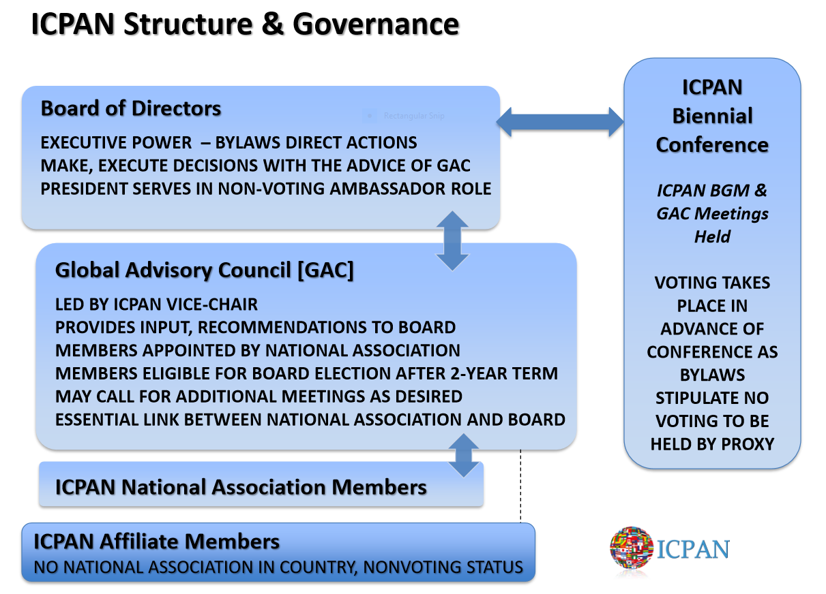
- Transitional Board Reports

- Chair Report
Transitional Board of Directors Accomplishments
- Secured indemnity insurance
- Operationalized Bylaws
- Identified strategic mandates, Set 2-year timeline for completion
- Held regular monthly meetings beginning October 2015
- Established process for organizational, affiliate membership
- Established basic operational documents in consultation with GAC Representatives
- Maintained website, increased social media presence
- Assisted ACPAN in planning, marketing, development of 2017 Conference
- Established external professional relationships

Professional Connections
ICPAN has been involved in outreach, relationship building with other non-profit global health organisations to promote nursing involvement and safe surgery for all. Chair welcomed representatives from IFNA, Lifebox, and WFSA participating in 2017 conference.

Chair Report (continued)

Cameroon Outreach Success
The power from personal and professional connections with use of ICPAN social media led to direct education and mentorship for post anaesthesia care nurses in this African country currently lacking health care delivery resources and basic nursing education. Volunteer professional nurse educators Harriet Zych (UK) and Owen Ashwell (NZ) shared their story in a Sydney plenary session.
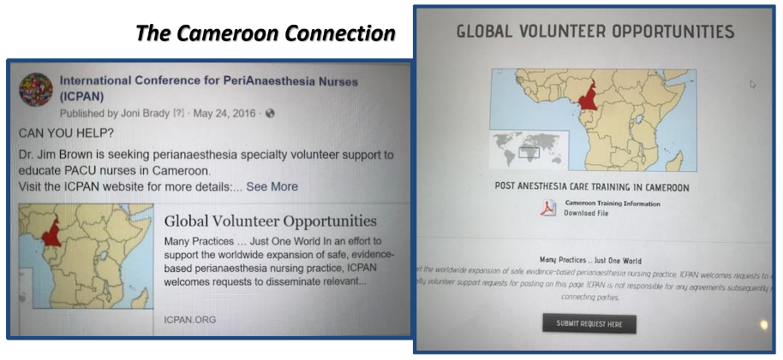

- Vice Chair Report (Sue Fossum on behalf of Pat Smedley)
GAC has advisory role to ICPAN board. Transitional Board in cooperation with GAC completed foundational work to operationalise the ICPAN Inc. Bylaws. 10 GAC meetings were held from May 2016- October 2017 with ICPAN policies and position descriptions reviewed and vetted. Each GAC Representative serves as an essential link between the National Association Member and the ICPAN Board, and through GAC service gain valuable ICPAN, Inc. knowledge/experience during 2-year term to support transition to Board leadership roles (ensure leadership resources are properly mentored for board sustainability).

Major GAC work achieved
- Establishment of ICPAN Conference Host Bid policy/procedure, related documents
- Tested bid scoring document to validate process
- ICPAN Board leaders emerge from GAC
- Appointed national organization representatives serve 2-year term to gain ICPAN knowledge, experience
- 2 members now candidates for 2017-2019 Board

Message shared from Transitional Vice Chair Pat Smedley: “Above all, regular communication between GAC members was informal but informative, fun, and created the foundation of strong international ties. To all GAC members, thanks for your expertise, support and collaboration!”

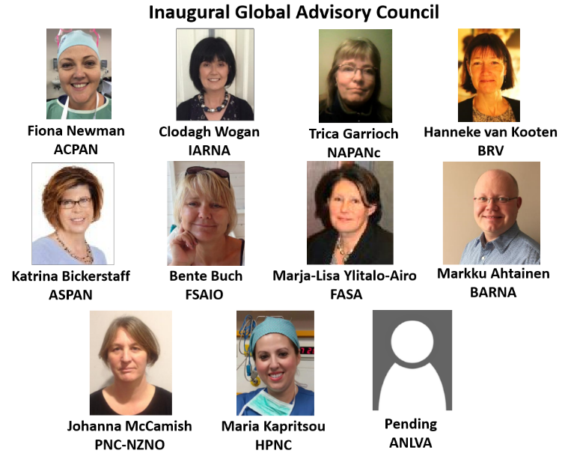

- Secretary Report (Joni Brady on behalf of Laura Van Loon)
Biennial Bylaws document review was completed in consultation with GAC. The Bylaws underwent minor revision for language parity across sections, and improved position function clarity. The revisions in no way impacted the role or powers of the GAC and were approved 11 July 2017.

Major work achieved
- Board, GAC meeting minutes documented, approved, catalogued as directed by non-profit legal counsel
- Job Descriptions developed for each Board position, GAC Member role
- Developed, approved operational policies
ICPAN Conference Host
Social Media
Board Election
- Archived organizational documents on secure Board and GAC webpages

- Treasurer Report

Financial Governance
- Banking : Citibank dual signatory international business account set up
- PayPal Membership Payment Platform introduced on website
- Monthly reporting to Board all transactions
- Internal Revenue Service (IRS) Filing completed annually in USA
- Hurwit & Associates retained as legal advisory service
- Director Insurance maintained

Treasurer Report (continued)

Annual Budget Presented
Income
- Member Fees – Tiered
- Sponsorship
Biannual Conference Profit Share (20%)
Expenditure
- Legal Fees (annual mail forwarding charge)
- Bank Fees (some waived due to non-profit status)
- Ongoing website management

Need exists to grow current resources to become able to underwrite mission goals. Future operational goals include securing Grant Monies, Education Development Fund.

- Membership Secretary Report
Reviewed Organisation and Affiliate Membership Categories as specified in the Bylaws. Benefits of Membership reviewed (available at http://www.icpan.org/uploads/5/7/6/2/57626711/icpan_membership_benefits_march_2017.pdf)

Membership application/payment system implemented on ICPAN website to reduce incoming and outgoing bank wire transfer fees encountered with 2015-2016 membership payments. PayPal membership is not needed to use the secure web platform - may scroll down and use credit card payment option.

Membership fee schedule reviewed http://www.icpan.org/membership-info.html

Current Organisational Members were sent renewal notice in October:
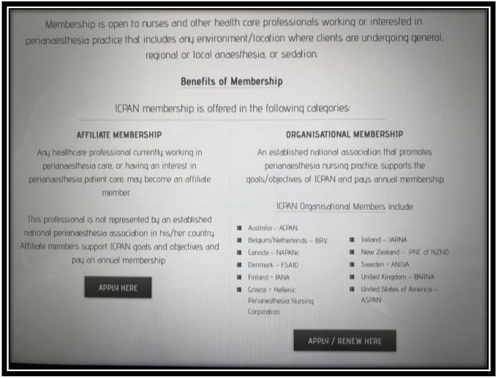
Australia – ACPAN
Belgium/Netherlands – BRV
Canada – NAPANc
Denmark – FSAIO
Finland – FANA
Greece – HPNC
Ireland – IARNA
New Zealand – ​PNC of NZNO
Sweden - ANIVA
United Kingdom – BARNA
United States of America – ASPAN

- 2017 Conference Chair Report
​"Tides of Change - Advocacy, Education, Research"- Luna Park, Sydney, Australia
- 398 registrations, 14 countries / 5 continents represented
- In country support: Jayne Hindle and East Coast Conferences Team

Thanks given to Sponsors
- Fresenius Kabi Australia, Intersurgical Australia, Karl Storz Endoscopy

Thanks given to Exhibitors

- MDevices
- Aspen Pharmacare Australia Pty Ltd
- Fisher & Paykel Healthcare
- Intersurgical Australia
- Fresenius Kabi Australia
- University of Tasmania
- Vyaire Medical
- Teleflex Medical Australia

Generous Silent Auction donations acknowledged with appreciation.

- Education Chair Report
2019 Conference Bid policy/process followed. No organisational member bids received; ICPAN will host the conference per policy with location to be announced during Conference Closing Remarks.

Website Forums http://www.icpan.org/networking.html#/ were set up to encourage peer networking as suggested by 2015 delegate evaluations. Forums a work in progress, not many participants at this point.

Vision for Future: Promote best practice through research, evidence based education tools, practice guidelines, etc. Collaborate with the membership to find out what can ICPAN as an organization do to assist perianaesthesia nurses in providing skilled compassionate care to our patients.

- Marketing/Media Coordinator
Webmaster Michael Maino (paid contractor) provided activity report to Board prior to conference:
- Website launched in August 2015; translation button placed on pages where available
- Performed monthly maintenance, new builds, activity reports, Board and GAC secure access permissions
- Weebly website hosting agreement and “icpan.org” email accounts renewed to 2019
- Policies, job descriptions, Bylaws, financial reports posted, available using secure Board and GAC login access

Marketing/Media (Continued)
- Networking Forums developed, tested, launched in 2016
- Online membership application and secure payment system developed, tested, launched April 2017
- ICPAN Facebook Page shows broad global engagement. “Likes” (over 900) doubled in number since 2015 conference, diverse locations increasing weekly

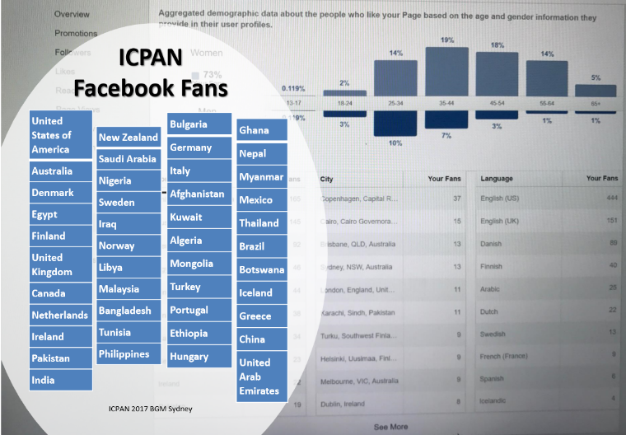

Recognition and thanks given to members who graciously helped spread the word about ICPAN 2017 over the past 2 years!
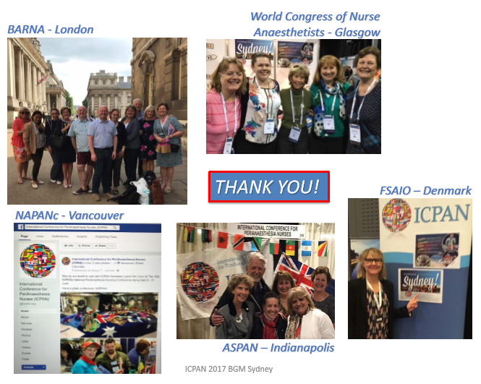
- 2017 Election Report – President (Nonvoting Board Member)
2017 Election Policy approved with input from GAC to establish a new process to pilot for ICPAN’s first election. Candidate eligibility defined, Call for Nominations sent to all current Board and GAC volunteers with candidate slate vetted. Election process included secure-blinded Board and GAC Survey Monkey ballots with member voting completed 24th October 2017. Ballots to be destroyed per policy. Results for 1st Elected ICPAN Board reported.

2017- 2019 Board of Directors

Chair – Dr. Joni Brady
Vice Chair – Dr. Maria Kapritsou
Treasurer – Meg Bumpstead
Secretary – Trica Garrioch
Education Chair – Angie Winter
Membership Secretary – Ann Hogan
President – Susan Fossum

No candidates declared interest in 2017-2019 Marketing/Media Coordinator position. Per policy this vacancy can be filled by Board appointment. Call for interest made by Chair to all present. ICPAN Conference Chair position will be appointed by newly elected board as it will serve as 2019 Conference host. ICPAN President serves by Board appointment.

Meeting Adjourned at 12:45 to accommodate delegate lunch service. Chair postponed additional comments, will include remaining slides/comments during Saturday’s closing remarks.

4 November 2017 Addendum : Closing Remarks 2017-2019 ICPAN Chair

Wide international variations exist in basic health professions education and provision of safe surgical and anaesthetic care. In a world with significant health care infrastructure gaps, many resource poor countries have significant need and patients experience harm, while wealthy nation practitioners have easy access to available resources.
http://www.sigmanursing.org/connect-engage/our-global-impact/stti-and-the-united-nations

Attendance at the 2017 Emerging Global Leader Institute provided an understanding of issues facing global non-profit organisations, potential resource sources, and reinforced the need to first identify key goals and develop a measurable strategic plan. ICPAN leaders working with the GAC will focus on the strategic mission and realistically assess capabilities and growth of a still developing organisation.

ICPAN and its members are largely all-volunteer work teams having very different cultural experiences and perspectives yet share a fundamental professional passion and bond. The leadership desires to promote work : life balance for professional volunteers to realize mission success and optimal recruitment and retention. Continued discussion is needed for consensus on systems that reduce cost/workload and increase efficiency. Surgery requires a team-based approach to ensure safe patient care. Experience in our chosen profession is needed at the global table to provide expert support for populations without access to perianaesthesia education and mentorship. ICPAN 2019 will be held in Cancun, Mexico in early November – dates to be determined and announced in the new year.

