Item | Subject | Background | Discussion / Motion | Action Item (Responsible)
1 | Call to Order (JB) | Welcome  Files posted (password: icpanista) http://www.icpan.org/401/login.php?redirect=/board-member-login.html | Convened via Skype @
2 | Attendance (MB) | Regrets: Meg Bumpstead, Suzi Querrell | Present:
3 | Approve Agenda (JB) | Additions? | I move to approve the 14/15 March 2017 board meeting agenda as presented: LV/
4 | Approve Meeting Minutes (LV) | Edited draft minutes circulated via email/posted on web meeting page | I move to approve the Febeuary 14/15 2017 board meeting minutes as presented (or amended): LV/
5 | Financial Report (MB) | ICPAN, Inc. Sponsorship prospectus in development
6 | Chair and Marketing/Media Update (JB) | New menu tab added for “Sponsorship” hidden in navigation until ICPAN, Inc. sponsorship packet ready to post  12 March 2017:  ICPAN, Inc. update sent to member organization leaders and GAC, copied to Board. File posted on web meeting page  Chair will be attending ASPAN, BARNA conferences/exhibitions to promote ICPAN & Conference | - Shorter logo/graphic considered by Board: will use existing 2013 version provided by AH as needed in marketing materials  - Weekly website stats growing  - Screenshots/reports posted on web meeting page  - 3 March Facebook posting made re: delay in speaker notifications; 10-12 March - received 2 queries regarding late speaker notification, 1 for conference program availability  - Webmaster Michael Maino researching Weebly site software hosting option for membership categories (i.e., new and renewal)  - Speaker request (via website query) received by Membership Chair. Removal of 2013 presentation from website executed on same day, speaker notified of action by Acting Marketing-Media Chair email; message receipt confirmed by speaker  - Chair to contact colleagues to request voluntary participation in exhibition stands at respective conferences
Item | Subject | Background | Discussion / Motion | Action Item (Responsible)
7 | Conference Host Policy to Accompany Conference Bid Documents (SF, AH, PS) | Bid documents were approved by Board/GAC. Files posted on 8 January 2017 meeting page  Bundled files  Advice to National Associations  Advice to Reviewers  Bid Form  Guidelines for choosing PCO  Conference Site Specifications | Finalized conference policy document and distributed to GAC  for feedback (PS, SF)  Action Item: Develop host country bid acceptance document stating terms of conference policy have been reviewed, are understood (JB)  - Draft host country bid acceptance document posted on meeting webpage for review, discussion.  (Motion to approve?)  2019 Bid timeline:  - End of April: Issue call for bid applications  - July 1st: Close bidding  - July 2-August 14: BOD/GAC review/score bids  - August 15: GAC recommendation goes to BOD  - September 1: top bid host notified by Chair  - September 15: Bid acceptance form returned to Chair  - November: Announce at Closing in Sydney | Post final version of approved documents on appropriate Board/GAC secure login web pages (JB)
8 | 2017 Conference Update (AW) | Oral abstract review team assignments completed via PCO submission process  Poster abstract submission deadline 1 June 2017 | - Draft program, budget, PowerPoint promotional file from PCO posted with meeting files and on Board login page under 2017 Conference  - Update (AW): March meeting with PCO  - Programme  - Hospital tours  - Optional Pre-workshops  - Next PCO meeting on 2-3 April  LifeBox/WCNA confirmed :  AU rep will attend, airing of The Checklist Effect video | Poster abstract review begins 2 June (AW)
9 | Membership Policy and Report (AW) | Benefits of Membership and Membership Policy draft documents shared in advance by email for comments | - Benefits of membership query from Croatia, Phillippines  - Benefits of Membership document draft for approval  - Membership policy discussion: Vote?
Item | Subject | Background | Discussion / Motion | Action Item (Responsible)
10 | ICPAN Elections (SF) | Establish process/policy to guide 2017 Board election | President drafted policy for consideration- All were to review/send feedback to Sue Fossum  Review, discuss final draft : Vote?
11 | Chair & Marketing/Media Job Description (LV, JB)  Drafts developed, posted on secure meeting page for review, decision by BoD |  | Chair JD  Markewting Media JD | Post all final approved JDs on GAC secure login page for review/ election recruitment (LV/JB)
12 | Marketing/Media Report (JB)  Membership Renewal via Website Investigation  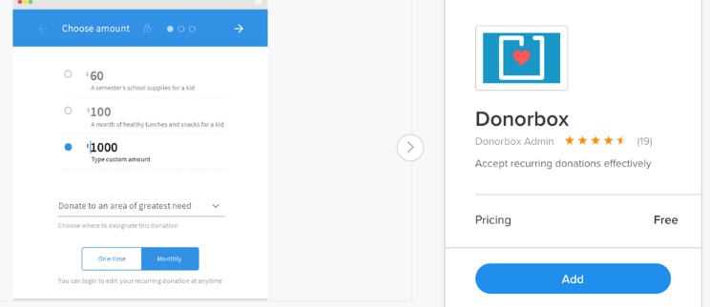  JB will exhibit at ASPAN – will ask BARNA for a space. Can we identify reps attending other conferences through GAC? |  | Michael Maino reports:  Here’s the results from the research I did on accepting membership fees on the website. It looks like we won’t need to upgrade our current Weebly membership level in order to make this possible. There appears to be built in third party options that can accept payments on the website for free. The two options are:  1) Paypal button with pricing chart below  2) Donor box which is completely free  Based on what I understand from your expectations, I believe Paypal is the better option as it’s a more commonly used/known platform. It’s free to have in the website if you accept less than 100 transactions per month. If you need to accept more than that, it looks like there is slightly additional fees that will need to be paid.  P.S. Here is my address:  925 N. Garfield St APT 302  Arlington, VA 22201
 | Next Meeting |  | Date for next meeting:  Meeting adjourned @

