ICPAN 2017 Registration Fees
All fees GST inclusive, and in Australian dollars.

Conference Registration | ‘Early’ Registration  (by 1 September 2017) | Regular Registration  (after 1 September 2017)
Full Registration  Includes all Conference Sessions & Welcome Reception | $750 | $900
Additional ticket – Welcome Reception (Wednesday 1st November 2017)  Note: This is included with all Full Registrations. Tickets can be purchased for partners and accompanying guests. The Welcome Reception will be held amongst the trade exhibition displays at Luna Park Sydney. | $70 | $70
Conference Dinner (Thursday 2nd November 2017)  Note: This is an optional extra, and is not included in any of the registration fees. The Conference Dinner will be held on “Sydney Showboats” and includes a 3 hour Sydney Harbour cruise, 3 course meal, drinks and entertainment. | $150 | $150

Accommodation
Accommodation block bookings have been made at North Sydney Harbourview Hotel (15 minute walk to venue, or one train stop) and Rydges North Sydney (25-30 minute walk to conference venue, or 13 minutes by bus). Special conference rates have been negotiated. Bookings for these rates are available via the registration form (not directly with the hotel). The rates listed are room only and are for the conference dates only.
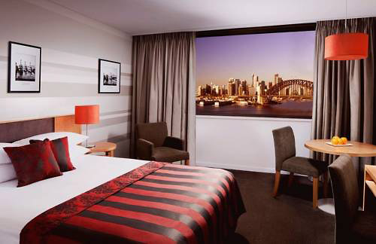

North Sydney Harbourview Hotel
17 Blue Street
NORTH SYDNEY
www.viewhotels.com.au
Queen Harbourview Room – $245 per night (room only)

Fact Sheet
________________

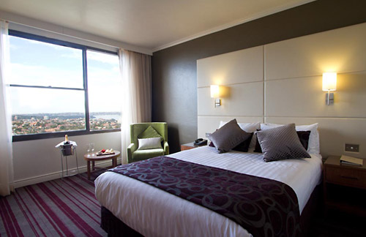

Rydges North Sydney
54 McLaren Street
NORTH SYDNEY NSW 2060
www.rydges.com
Parkview Queen Room – $275 per night (room only)

Fact Sheet

