Hi Everyone:
I’ve spoken with most of you over the past 2 weeks to continue our work on action items, and we’re making steady progress

Tuesday 6/13-14 Board Meeting cancelled.
I’ve received regrets from Meg (work related travel), Ann (Croatian holidays :), Pat (travel day for BARNA conference) and Laura (headed for holidays after NAPANc Conference this weekend). Safe travels, guys ~~~ and have fun (and great success, Meg)!

Please be aware that Suzi will no longer serve as Conference Chair due to personal demands surrounding family relocation. We appreciate past efforts and support her need to put family first. Fiona will now be listed as the 2017 Chair on the website and, understandably with work hours in AU and our regular meeting time, may be hard pressed to attend more meetings due to existing demands. This is fine as Meg, Angie, Fiona and I have teamed up to divide and conquer logistics for conference planning with ACPAN PCO Jayne. We all together form a strong team and we’ll call on each of you to support scientific programme / formal meetings planning as we near conference time. Huge thanks to Angie, Fiona and Meg for continued perseverance and commitment to make the 2017 conference a success!

Updates

Sweden now an official ICPAN member
- Welcome email sent (Joni), connected with Pat/Sue for GAC follow-up
- Space added to GAC page … but GAC rep appointment is still pending
- Added conference info link http://www.icpan.org/global-activities.html
- Greece coming on board very soon – Maria anticipates having needed tax ID number any day
- Please send updated GAC contact list (replace outdated copy on secure GAC login webpage)

2017 Conference
As of 7 June registration = 264 (early full registrations = 163). Budgeted 400 delegates.
- Agreed to extend early registration discount to 30 June to encourage more participation, give poster abstract folks a chance to confirm/register
  - Announced extension on icpan.org and Facebook page (8 June)
  - PCO has not yet made date change to conference site
- Exhibition participation increasing – currently @ approximately 44% of budgeted amount
- ABPANC review for US continuing ed certification credit underway by CEO Bonnie Niebuhr
  - Second request made to PCO to post website statement on US recert credit
  - Requested blurb inclusion in next blast email, will put something on Facebook page
- Programme planning continues with monthly PCO meeting held (next 6/23-24)
- ACPAN has graciously offered an invitation to ICPAN Board members to attend the dinner cruise as a guest. So nice! If you’ve already paid your ticket price can be refunded

2019 Bid request sent to all member organisations on 6 May
- Sent second message to confirm that all org leaders had received this information
- No requests for a bid packet, no expression of interest received to date

Continuing Action Items

- 2017 Conference

  - Please direct all potential conference exhibitors to the prospectus and Jayne at East Coast Conferences http://www.icpan2017.com.au/sponsorship/
  - Need volunteer to coordinate 2017 Silent Auction: plan to assign ACPAN Board members to oversee auction table bidding on site in Sydney
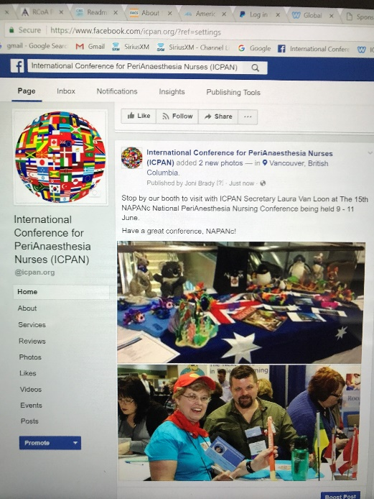
  - Angie working on poster abstract review/logistics
  - Joni, Bente, Mette, Ellen working on Delegate Forum plans. May need all of you to help with this session on site in Sydney
  - Angie, Joni coordinating preconference workshops with faculty/PCO
  - Meg, Fiona to visit Sydney venue in late June, will follow-up on hospital tour sites/plans
  - Joni to collate delegate handbook: will ask Board to proof read drafts in September timeframe
  - Sue offered to format delegate attendance certificate when ABPANC info has been returned
  - Promotion: Laura has booth at NAPANc this weekend, Joni has stand at BARNA next week
ICPAN Facebook Page: NAPANc 10 June 2017 Vancouver BC
  - ICPAN website, Facebook hits very active

- 2019 Bid
  - Will discuss our next steps during next Board meeting
  - Please be thinking about possible host sites with ICPAN leading 2019 conference

- Online Membership Payment System
Renewal period set, action plan in place (Ann, Meg). Meg, Joni have access to PayPal account, which is tied to ICPAN’s Citibank account. Ann, Joni, Michael met 6 June to finalize pages. PayPal account tested - system does generate an email to Ann, Meg to provide affiliate fill-in form contents.
- Org membership page revised for clarity/ease of use
  - Needs testing
- Online member payment receipt needs adjustment to vendor name (ICPAN, Inc) to display properly
  - Joni will continue to work the PayPal issue (banking stuff is tedious but getting close to done), test revised org member application forms to ensure Ann, Meg get those messages

From Michael:

The current membership page is hidden on the website but you can access it with this link: http://www.icpan.org/membership.html

This page links to the two separate form pages for Affiliate and Organizational memberships respectively. <<<>>> When somebody submits the form, it will send the results to Ann’s email (ann4icpan@gmail.com).

Affiliate: http://www.icpan.org/Affiliate-Membership-Payment.html
Organisational: http://www.icpan.org/Organisational-Membership-Payment.html

- Job Descriptions, Bylaws Review
  - Membership/Marketing job description (JD) may be revised, expanded to 2-person position
    - Opportunity to improve overall board operations
    - Joni, Laura to discuss after Laura’s holidays conclude
  - Chair JD remains under review due to potential Bylaws conflict
    - Laura, Joni raised question for Bylaws review/discussion prior to vote on Chair JD
    - ICPAN’s pro bono attorney conducting a review, making recommendation
  - Secretary Laura to catalog policies, procedures, JDs for secure web posting, presentation at BGM in Sydney

- GAC and Election 2017
Posted copies of final approved JDs on GAC secure login page to make available for review by potential candidates. Election policy completed. Need to create secure Survey Monkey voting form once candidate slate is drafted per schedule.
- Transitional Board and GAC provide candidates; per Pat, one nomination confirmed (secretary)
- Sue will manage election process per set plans/timeline

The upcoming annual holiday season may impact meeting attendance and, if so, we can juggle the current schedule to better accommodate everyone’s needed downtime. I will be all over for next 6 weeks with our upcoming move, but will have internet and mobile access throughout the transition period. Please email ASAP if you can’t attend the regularly scheduled meeting on 11-12 July. Based on your replies, Laura and I will be in touch about action items and next meeting.

Surely, I’ve forgotten something … but this will help to catch you up on our activities for now. Thanks for all you do to support our shared goals for ICPAN and ACPAN! Have a lovely weekend! Joni

